Coat Hooks
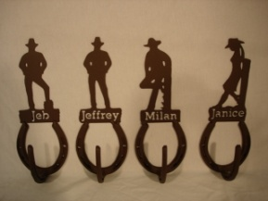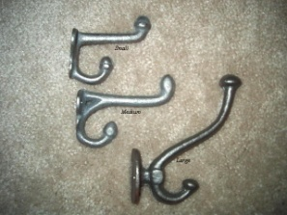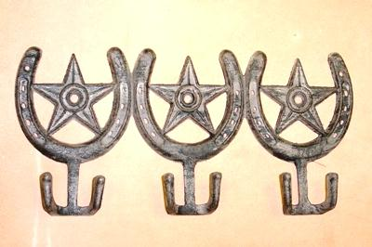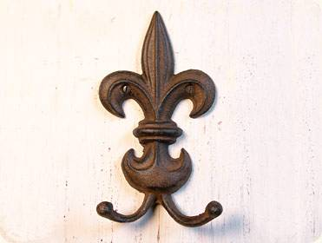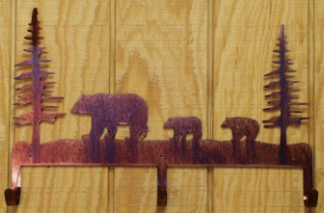
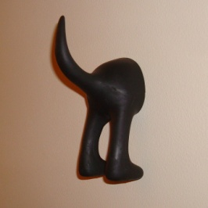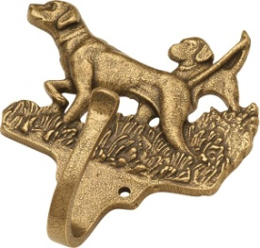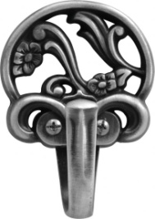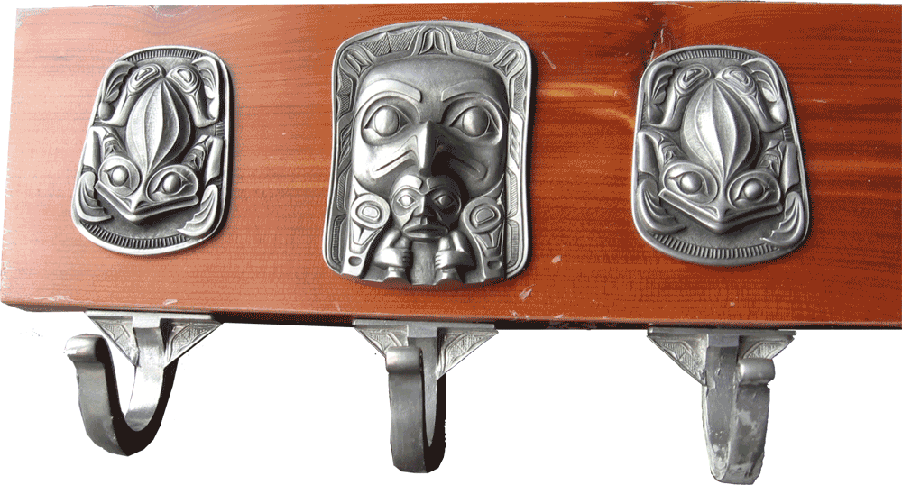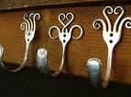

Sources:
http://oldwestblacksmith.net/images/custom%20cowboy%20coat%20hooks.jpg
http://westerngeneralstore.com/images/Hooks%20and%20Hangers/Hooks_Coat_Sm_T245_Md_T244_Lg_T243.JPG
http://i.ehow.com/images/GlobalPhoto/Articles/5035772/203297-main_Full.jpg
http://bearcreekgifts.com/cart/images/DESIGNS%20BY%20TRENDSETTERS%20713.jpg
http://www.tomfotherby.com/Images/House/coatHookDogAss.jpg
http://prod.coat-hooks.net/images/belwith/Large/P28652-AB.jpg
http://prod.coat-hooks.net/images/belwith/Large/P2134-SPA.jpg
http://www.gmsculpting.com/images/Miniature/Coat_hooks2.gif
http://images.google.com/imgres?imgurl=http://salamancamarket.files.wordpress.com/2008/07/fork-hooks.jpg&imgrefurl=http://salamancamarket.wordpress.com/forkometry-silverware-cutlery-creations/&usg=__xmSHUnIx-0Qw_bcfdDtZ2Y4BoGs=&h=593&w=800&sz=420&hl=en&start=612&sig2=qMZ8ncb9iN9EXjRP7GMGog&tbnid=9ztHw6uerd-3uM:&tbnh=106&tbnw=143&prev=/images%3Fq%3Dcoat%2Bhooks%26gbv%3D2%26ndsp%3D18%26hl%3Den%26safe%3Dactive%26sa%3DN%26start%3D594&ei=105PS8SVNdSPtgeUrqzYAw

Flower Vase
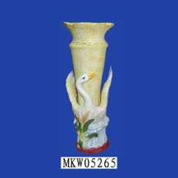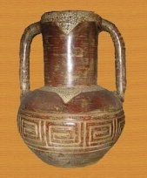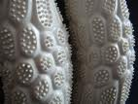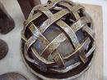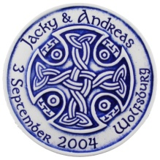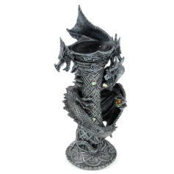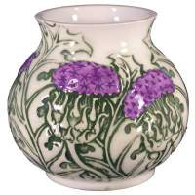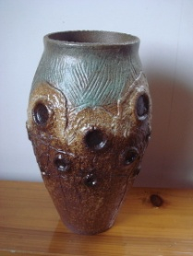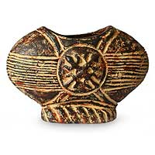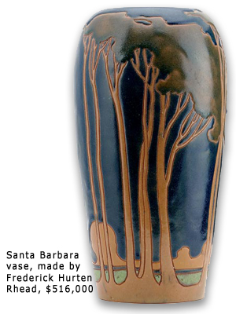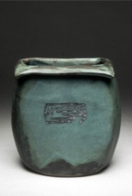

Sources:
http://1.bp.blogspot.com/_2HEOVX8kT24/Sdn5WKRR1MI/AAAAAAAAAFc/yfHkKfx_6nk/s320/Ceramic+flower+vase+antique+handicraft+of+the+natural+products_001+.jpg
http://images.google.com/imgres?imgurl=http://littleblackbookofart.files.wordpress.com/2009/10/ribosome-flower-vase-closed_72dpi.jpg&imgrefurl=http://littleblackbookofart.com/category/artist-of-the-week/&usg=__vnTIvXQATLn7xfeyypJ2wM_kNKE=&h=567&w=756&sz=349&hl=en&start=38&sig2=lvZ2h8Hmy35sfPQkpXkfvA&tbnid=QZRDAdUujDBaiM:&tbnh=107&tbnw=142&prev=/images%3Fq%3Dflower%2Bvase%2Bceramic%26gbv%3D2%26ndsp%3D18%26hl%3Den%26safe%3Dactive%26sa%3DN%26start%3D36&ei=xk9PS935JYiVtgf24ciWCQ
http://images.google.com/imgres?imgurl=http://jaredinnakano.files.wordpress.com/2009/05/bizen_fancy_lattice_flower_.jpg&imgrefurl=http://jaredinnakano.wordpress.com/tag/in-laws/&usg=__zoVkao-_q1zc0s6SJ--ZLVU6yRY=&h=375&w=500&sz=27&hl=en&start=68&sig2=K9M1rzmIeJFODgv9ARfUBw&tbnid=KOLD3L_09V2glM:&tbnh=98&tbnw=130&prev=/images%3Fq%3Dflower%2Bvase%2Bceramic%26gbv%3D2%26ndsp%3D18%26hl%3Den%26safe%3Dactive%26sa%3DN%26start%3D54&ei=A1BPS7K4BYWVtgfFoKmYCQ
http://www.jsfavours.co.uk/images/coasters/celtic_design_8.jpg
http://pix.white-elephant.co.uk/pix/d/DRG166_001.jpg
http://www.jsceramics.co.uk/images/jsc/Thistle_vase.jpg
http://www.aspencountry.com/assets/product_images/product_lib/34000-34999/34120.gif
http://www.china-yxceramic.com/upload/news_2009419162410.jpg
http://pics.novica.com/pictures/5/p154695_1.jpg
http://3.bp.blogspot.com/_zqFoq3qej2c/R32ZPlwBnjI/AAAAAAAAHr0/54niZrhoVuY/s400/rhead-vase.jpg
http://dwinbergpotteryikebana.com/yahoo_site_admin/assets/images/p_lee_feb_06_003.20143712_std.jpg

Soup Bowl
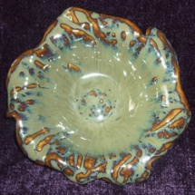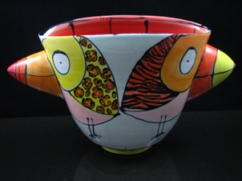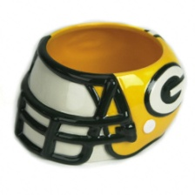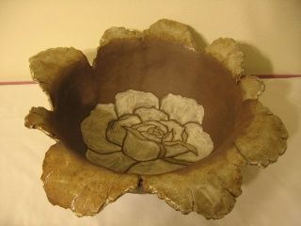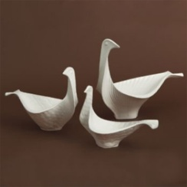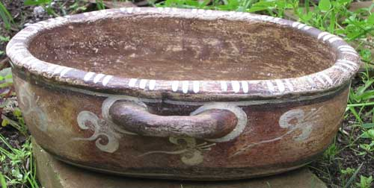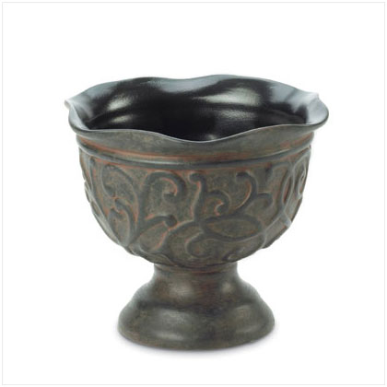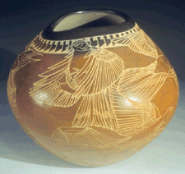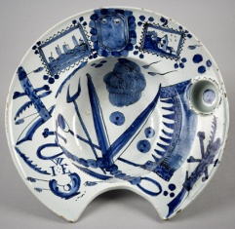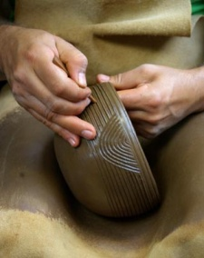
Sources:
http://www.ceramicsinbloom.com/show-image/352909/Sheri-Hubbard/MS-Mud-Splatter-Soup-Salad-Bowl.jpg
http://www.redravenartcompany.com/artists/past/ashope/image/Birds%20Gone%20Wild%20Double%20Beak%20Bird%20Bowl.jpg
http://product.images.fansedge.com/35-80/35-80318-F.jpg
http://3.bp.blogspot.com/_pYKo2hD_orI/STEOKOgvKeI/AAAAAAAAAB4/ejbcMWtj40w/S660/Atsuko%27s+Art+032.jpg
http://2.bp.blogspot.com/_n1Jgy6WlY9E/ShHF6-7HXcI/AAAAAAAABgs/qx-oe_azFkU/s400/j+adler+bird+bowl.jpg
http://www.pcrm.org/gala/auction_images/Petersen-bowl.jpg
http://www.aspencountry.com/assets/product_images/product_lib/37000-37999/37309.jpg
http://www.aaawt.com/web_images/310-67_Delft-Barbers-Bowl_1.jpg
http://lapalmaisland.sheilacrosby.com/uploaded_images/mazo/molino248b.jpg

Cup
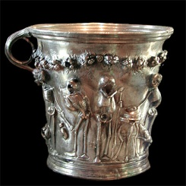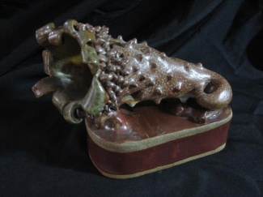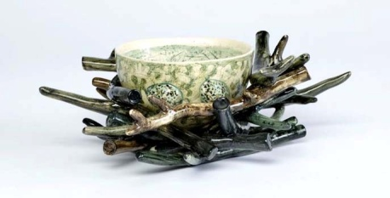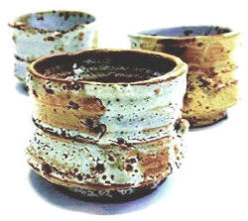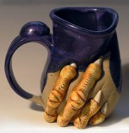
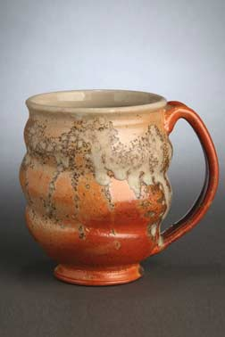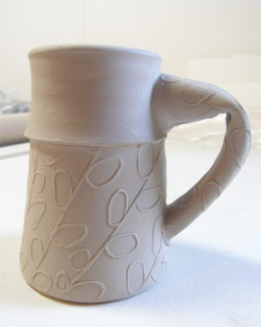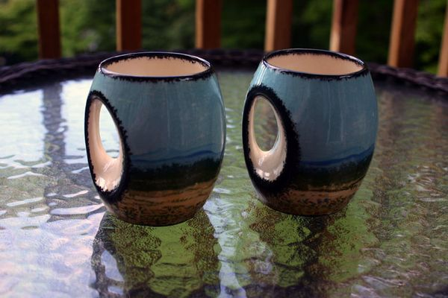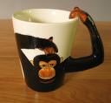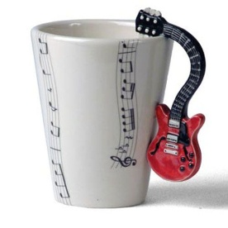
Sources:
http://www.vroma.org/images/mcmanus_images/skeleton_cup.jpg
http://fineartamerica.com/images-medium/non-functional-cup-kelly-butz.jpg
http://www.ceramics.org.uk/artistInfo/sqlImg/lambert%202.jpg
http://www.clayexpression.com/adults.thumb.size.pics/shinos-cup-m2.jpg
http://newsroom.hacc.edu/images/82//large_purple_mug_thumb_1253_4694.jpg
http://www.youristpottery.com/images/gallery/03_mugshin.jpg
http://coloradoartstudio.com/wp-content/uploads/2008/11/linoleum-0011.jpg
http://backyardneighbor.typepad.com/.a/6a00e552178e49883301157255311e970b-600wi
http://images.google.com/imgres?imgurl=http://www.daisydaisyethicalgifts.co.uk/images/monkey%2520mug.JPG&imgrefurl=http://www.daisydaisyethicalgifts.co.uk/Kitchenware/Monkey_Mug&usg=__7z7WyLzPDiIl3s8YV2ZgfAcXprc=&h=418&w=454&sz=19&hl=en&start=111&sig2=ky5MKSZVHrjdY-yF9ANfBg&tbnid=tfp1pXxBm1cmSM:&tbnh=118&tbnw=128&prev=/images%3Fq%3Dceramic%2Bmug%2Bhandles%26gbv%3D2%26ndsp%3D18%26hl%3Den%26safe%3Dactive%26sa%3DN%26start%3D108&ei=HlhPS6_-Boq1tgfn3aAB
http://www.musicroom.com/Images/Catalogue/fullsize/CRI003.jpg

